Invitational Report: Mark Rosewater Part 2
Mark Rosewater

Sydney
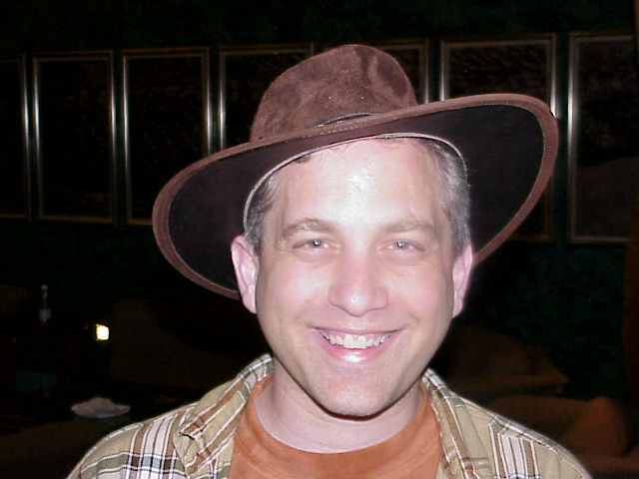
'G'day, mate' or no?
Let me sum up my week as a tourist in Sydney as one of the best vacations I've had. Unlike the week that followed, it was sunny and beautiful. It was during this time that I acquired my Aboriginal hat. This is the hat Chris Pikula dubbed the "Crocodile Dundee" hat in his report. To this day I still wear it with pride.
As the week elapsed, different Invitational players started showing up. One of my favorite nights was when my family, Gary Wise, Kai Budde, and Ben Seck (our Australian tour guide) went to a seafood restaurant which overlooks the Sydney Opera House.

The Player Meeting
When the players accept the invitation to the Invitational, they agree to certain responsibilities. The first one is a mandatory attendance at the player meeting. This meeting is very important as the Invitational has events beyond the tournament itself. In addition, the event changes locales and has numerous new formats creating a great potential for confusion. The players were informed ahead of time that we would be meeting in the lobby at 6pm. (This was Tuesday for those keeping track of how the week progresses.)
Most of the players were already in the lobby as they had been playing a draft for the last four hours. Come six o'clock, fourteen players had arrived for the meeting. Mike Long and Trevor Blackwell had not yet arrived. I called up to their rooms. No luck. I talked to their respective roommates. The best I could get was they went out to see the city hours ago. No wanting to wait forever, I started the meeting. Remember that Long had already caused a mini-controversy for being invited despite the fact that he had not turned his report in on time. Suffice it to say that Long is not the most popular invitee and numerous players felt compelled to bring up Long's absence continually throughout the meeting. This ended once Long and Blackwell finally showed up twenty minutes into the meeting.
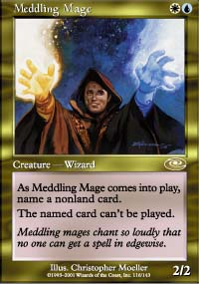
The highlights of this meeting was the unveiling of Meddling Mage, the card Pikula had designed for winning Kuala Lumpur. While Pikula seemed very happy with his card, he made the unfortunate mistake of mentioning that he doesn't want his co-workers to see it as it reinforces all the false images they have of Magic. I imagined numerous envelopes arriving at Pikula's work the day after Planeshift was released. I had mocked up a copy of the card and put into a thick plastic casing. I do this every year as a trophy to give to the previous year's winner. The biggest difference is that in past year's the expansion with the card was not months away. (Avalanche Riders was in the prerelease the same weekend as Barcelona while Rootwater Thief had already premiered before Kuala Lumpur.)
A quick aside: I've been contacted by Olle Rade who asked permission to make the card he won the rights to back in Hong Kong in 1997. I got permission to make Olle's card and had him send me his submission. Olle and I chatted at PT-Tokyo and we worked out his submission. For those interested Olle's card as submitted is:
Olle's Card
Creature - ??
1/1
Sacrifice a land: Target creature you control cannot be the target of spells or abilities until end of turn.
Back to Sydney:
At the end of the meeting, the players all had to turn in their card they planned to submit if they won. As a full-time Magic designer, I always get a kick out seeing what the players come up with. The player that has impressed me most with his skills as a card designer was none other than Zvi Mowshowitz. Check out their submissions here.
After the meeting, my family and a number of players (Pikula, Price, Wise, Ishii, Shvartsman) and assorted others (Randy Buehler, Ben Seck) went to a Thai food place called Thaifoon. One of my favorite parts of the Invitational are the dinners. Normally at a Pro Tour the staff does not eat with the players until after they are out of contention. The Invitational is a little more casual, and lengthier, than the Pro Tour and allows me more off-time with the players.

Tour Day

Pikula can make all the fun of my hat that he wants. With all the rain, it proved very useful on tour day.
Wednesday is always tour day. Tour day serves three important functions. First, it allows the players a chance to see the exotic city we have brought them to. Well, at least in theory. The bus tour proved to be the most disappointing one to date as it was pouring rain and very misty meaning that we could see next to nothing from the bus. This didn't bother me personally as I had just spent a week in Sydney, but I felt bad for the players. Too much of the time, Magic pro players fly around the world to exotic places and spend all of their time inside playing. I think it's important to occasionally stop and take the time to appreciate the interesting places and cultures into which they have ventured.
Number two, the tour day gives all the players a chance to bond. While most of the players know each other, there are always a few relatively new faces (Yoshikazu Ishii, as an example, this year). Third, the tour allows us a chance to get the location photos we need to cover the event. This year proved to be more challenging as the rain would not let up. This meant the players took turns standing in the pouring rain in front of the Sydney Opera House while our photographer, Craig, took their pictures. While this probably does not seem like much fun, it was one of my favorite memories of the event. The players embraced their photo duties with much zeal and a great number of silly pictures were taken (a number of which made their way to the Invitational coverage). Pikula can make all the fun of my hat that he wants. With all the rain, it proved very useful on tour day.
Like the player meeting, two players were late, except this time they were Mike Long (who I had to wake up) and Ryan Fuller. Luckily, we managed to get both of them before we left with the tour bus.

Player Dinner #1

It's interesting to see what non-Magic topics come-up when Magic players sit down over a meal and chat...
One of the many perks of the Invitational is that Wizards takes all the invitees out to eat on numerous occasions. The first player dinner was the night of the tour. To be honest, this year's restaurants did not reach the highs of some previous Invitational dinners (the Brazilian meat-apalooza with the special meat dial will always hold a warm place in my heart - more on the meat dial later), but hey free food is free food. The first dinner was held in a restaurant in the hotel.
As I mentioned earlier, I have always enjoyed the camaraderie of the Invitational. It's interesting to see what non-Magic topics come-up when Magic players sit down over a meal and chat. (This reminds me of a very famous event known in Pro Tour history as The Dinner which occurred on the last night of Pro Tour-Mainz, but that story's for another time.) All in all, the dinner lasted three hours with topics ranging from politics (remember that the U.S. election had just ended in a tie) to bad, but enjoyable movies.
The final important event of the dinner was my chat with Mike Long. When players accept their invitation to the Invitational they have to agree to a list of responsibilities. These responsibilities are not all that arduous (show up for all the key events, do some gunslinging, write a tournament report, etc.) but they are key to the event. I pulled Mike aside to stress that he had already slid on two of his responsibilities (attending the player meeting and player tour) and that he was on thin ice. I told him he was on probation for the rest of the event and that any failure to live up to his responsibilities would impact negatively on him. Mike apologized and promised to be good for the rest of the event.

Duplicate Limited (Rounds 1-3)
The Invitational has a few traditions. One, is that it always includes Duplicate Limited and two, that it's always held first. The Invitational is not your average tournament and Duplicate Limited is always a good way to remind the players of what they've gotten themselves into.
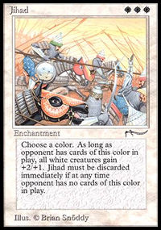
As everyone opened their packs, I watched to see what kind of reaction the different players would have. Everyone seemed to enjoy the obvious twist (familiar cards with new mana costs) and were happy to see many old cards (like Oubliette and Jihad) showing up. Enjoyment soon turned to panic though as the players realized that the hour of deck construction might not be enough. The players are used to understanding an environment before they build sealed decks. This makes deck construction very easy-going and relaxing. But with Duplicate Limited, there is a huge amount of information to absorb. In order to properly figure out the value of each card, they have to grasp the larger effect of the environment. I never make this easy so their work is always cut out for them.
Many of the players told me that they felt rushed by the end of the hour. But by the click of the final second, all the decklists had been turned in. Looking them over, one thing was sure, the annual Invitational tradition of overcompensating for weak colors in the Duplicate Limited playtest had happen yet again as all but two players used green in their deck. Other than the imbalance of green, the deck choices were all over the board. In fact, I believe 77 of the 96 cards available were either put into a deck or were sideboarded in during the three rounds.
Duplicate Limited matches are usually quite fun to watch as I weave all kind of goofy card interactions into the mix. I always enjoy walking around and seeing how different games are won. I was also very happy that numerous different strategies (weenie rush, board control, wacky combo, etc.) were played. All in all, the Duplicate Limited rounds ran very smoothly. All the players had a good time and no snafus occurred.
Traditionally at the Invitational, one player "gets hot" on the first day and just keeps winning until he makes it to the finals. Alex Shvartsman and Jon Finkel both went 3-0 so they seemed like the early runners for the hot player of the tournament. On the flip side, Kai Budde, Darwin Kastle, and Mike Long all went 0-3 taking a lead in the other real competition at the Invitational - not being last. Gary Wise incidentally went 2-1 in three rounds tying his win record from fifteen rounds in Malaysia.

Problem #1

Solomon draft rounds are the longest Magic rounds on the planet...
During the lunch break (yes, the Invitational actually has a luxurious enough schedule that we can afford a lunch break every day), I discovered the first problem of the event. Laura Waniuk (the Events Manager for APAC and Latin America) was the tournament organizer for the Invitational and Grand Prix-Sydney. She was checking in making sure that everything was okay. She casually reminded me that we needed to be out of the room by five thirty the next day for the Grand Prix trial.
As this was the first I had heard of a Grand Prix trial sharing our room, I was a bit surprised. "We won't be done by 5:30," I replied.
She said not to worry as she had checked the schedule and Friday was a short day with only four rounds. With our nine o'clock start time we'd have over eight hours. But these weren't any rounds. I had planned Friday with only four rounds because three of them were Solomon draft rounds. And Solomon draft rounds are the longest Magic rounds on the planet. Each round the players have to draft. This takes between forty-five minutes and an hour. Then the players have to build their decks. This takes about thirty minutes. Then they have to register their decks so we can post them on the web site. Finally, they play two out of three games with no time limit (the Invitational has no time limits to avoid unsportsmanlike issues like stalling). All in all, this takes two and a half to three hours. Assuming the short end of the spectrum and assuming we have no lunch, the three Solomon Draft rounds alone last seven and a half hours.
I stressed that there was no scenario by which we would be done by 5:30. Laura and I talked about solutions and Laura said she would look into getting an extra room.

B.Y.O.B. (Bring Your Own Block) - Rounds #4-6
One of my biggest fears about any new Constructed event is that there is one optimal deck that every player would play. The Invitational is at its heart a promotional event and having three rounds of monotony is a bad thing. The closest we came to the nightmare scenario was in Rio when twelve of the fifteen players (Jason Zila was a no-show) played Hanna in the Vanguard rounds. Three distinct deck types were played using Hanna so it didn't turn out as bad as it initially seemed.
My goal for the event was that at minimum seven different expansions got played. In the end eleven (Ice Age, Alliances, Visions, Weatherlight, Tempest, Stronghold, Exodus, Urza's Legacy, Urza's Destiny, Nemesis, and Invasion) sets were played with only five unplayed (Homelands, Mirage, Urza's Saga, Mercadian Masques, and Prophecy). On top of that there were a great number of different combination of expansions and numerous archetypes.
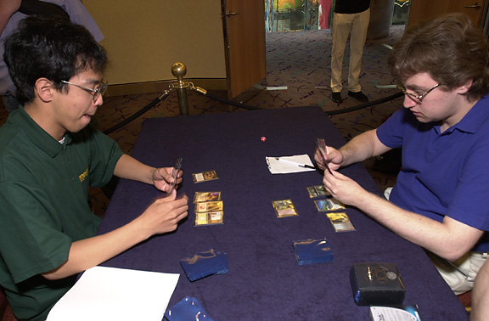
The most interesting deck was played by Yoshikazu Ishii who goes on record as the first player to play a Fires of Yavimaya deck at a premiere event. Because the Pro Tour two weeks later involved standard none of the other players wanted to give away Invasion tech. One of the best matches to watch was Gary Wise being eaten alive by Ishii's deck. Gary may be "loud and obnoxious" but he is one of the best losers in the game. (I've just finished typing that last sentence and I already know its going to be posted out of context on some web site.) Gary took his beating in very good spirit giving the rest of the players a running commentary.
From a metagame standpoint, it was interesting to note that seven players (Shvartsman, Price, Fuller, Long, Boeken, Blackwell, Godinez) played some version of Sligh with a combined 14-7 record.

Problem #2
Thursday night (between round five and six of B.Y.O.B.) I decided that I should check over all the Solomon draft materials before the next day. As I mentioned earlier I had relied on others to compile the eight copies of each draft pack. My gut told me that I should make sure there weren't any problems. Well, I've always trusted my instinct, and once again it proved correct. Two of the drafts (rounds #7 and #9) had errors. In each case an incorrect card had been added to one of the boosters. As each draft was themed, an incorrect card stood out like a sore thumb. For example, a red card would be noticed in an all gold draft.
I'm a big fan of puzzles. So, when I get myself in a bind I like to try to solve the problem as if it were a puzzle I read in a magazine. How do I solve this puzzle:
- In two drafts I am missing a card
- Both drafts are themed, the first is gold cards and the last is cards that interact with color
- I need eight copies of any new card and I have no cards other than what I brought for the tournament
I first thought about only having 95 cards instead of 96. I didn't like this choice as it would be obvious to the players that something was wrong. As such it was sure to disrupt the draft. Next, I tried to find replacement cards. I talked with Ben Seck, but my needs were so narrow that Ben wasn't able to help. Finding eight copies of Guma in an hour isn't easy.
The solution came to me thirty minutes before the first draft was about to begin. I did have other cards I could use: the cards in the two drafts not currently being drafted. While the players were finishing the last round of B.Y.O.B., I took eight copies of Vodalian Zombie out of the Draft #3 (Round #9) packs and put it into the Draft #1 (Round #7) packs. Then during the second draft, I would move the Vodalian Zombies and Surge of Strength to Draft #3 (Round #9). The only trick here was I had to make sure I got back all eight copies of the two cards. This shouldn't be too hard as all the cards are returned (they're on loan from R&D for the event), but if even a single player forgets to turn it in directly after the round, I would be screwed.

Solomon Draft - Rounds #7-9

All the other players refer to being paired against Pikula in Solomon as "getting the bye".
Other than Duplicate Limited, no format has been played more at the Invitational than Solomon Draft. The reason we use it so often is that it's a great draft format but is very hard to run logistically. Since the Invitational is such a small tournament with top tier players and a very relaxed schedule, it is the one tournament a year where we can run it. Also, as I explained earlier, it allows the audience to compare how the different players split the same packs.
The running joke in Solomon Draft is Pikula's complete inability to master the format. Coming into the event, Pikula had a 0-7 lifetime Invitational record (0-3 in Rio, 0-4 in Kuala Lumpur, this includes the draft in the finals). All the other players referred to being paired against Pikula in Solomon as "getting the bye". Pikula did try hard to end his streak but walked away with a 0-10 record. As I will explain later, Pikula managed to lose one more Solomon Draft before leaving Sydney.
As this was the first year I had made strong theme packs to draft, I was very excited to watch the players' reaction as the drafted the first pack of the first draft (all gold cards). The players have come to expect many surprises during the Invitational and everyone seemed quite amused by the all-gold draft.
I had set up the lunch break between the first and second Solomon draft. This would allow me time to swap the cards out of the Draft #1 and into Draft #3 packs. Once everyone had left for lunch, I counted up my Vodalian Zombies and Surges of Strength. I had seven. Trevor Blackwell had forgotten to turn his cards in and took them with him to lunch. Luckily, I had a draft as buffer and was able to retrieve the eighth copies from Blackwell.
The Solomon Drafts took a long time as expected, but it proved to be a fascinating format to watch. Figuring out the flavor of the draft on the fly and changing one's drafting strategies proved to be challenging for all of the players.
Draft #2 (Round #8) ended around five o'clock. Laura Waniuk had been able to secure another room but it was not big enough to hold the Grand Prix Trial. This meant we would have to move. I gave the players a short break while I went to check out the room. Earlier I had swung by to see a meeting in session. When I returned I found an empty room. And I mean an empty room.
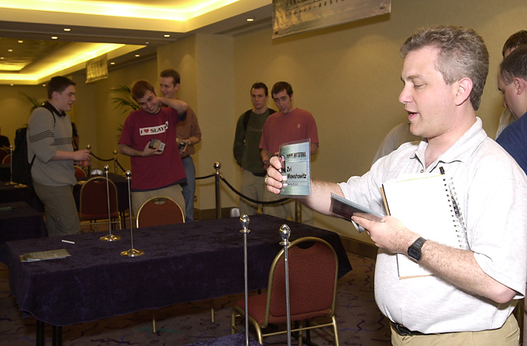
Mark Rosewater, famed Hollywood runner
It is moment like these that I flash back to my days as a "runner" in Hollywood. For those unfamiliar with Hollywood speak, "runner" is Hollywood for "slave". It is the lowest entry position where you work long hours for minimal pay doing things that make you feel something less than human. The idea is for you to make contacts and learn the business. I used to compare runners to plastic cogs. They're cheap and easily replaceable, but boy does trouble erupt if you don't have one when you need one.
One of my favorite runner stories happen at the Emmy awards. The first day at the site (the place where the event happened), I was called to the control room. This was almost always outside the building in a big truck. The moment I entered, the assistant barked the following order at me: "The director wants swordfish. You've got twenty minutes. Go!"
Translated into English, what she said was, "We are about twenty minutes away from the lunch break. I talked with the director and he said that he is feeling like having some swordfish. You need to get him the swordfish before the lunch break. Farewell."
Now, you have to understand that this was my first day not only on site but in the city of Pasadena. I had never set foot in a single restaurant. To top it off, I needed to return with a cooked swordfish. Assuming I knew where to acquire one, the cooking time alone was sure to sink me. That said, I did it. I was a fine runner. For those that care, I found a restaurant two streets over that had seafood and bought a swordfish from a man as it was being served to him.
The reason I bring up this little story is that after being a runner for two years, little ever intimidates me. Within ten minutes, I had four long tables and sixteen chairs. I didn't even realize the problem I had created until after the players entered the new room. I was about to run a Solomon draft with identical packs with players seated next to one another.
This problem was solved with only the materials at hand. All the long tables were actually two long thin tables pushed up against each other and covered with a tablecloth. By separating the small tables we were able to make eight skinny tables for the draft. The draft went quickly and we were soon done with day two.

The Auction of Champions - Rounds #10-12
One of the quirky elements of the Invitational is that Days 1 & 2 are always held at the hotel while Days 3 & 4 are held at the Grand Prix site. The site for Grand Prix-Sydney was at a convention center a relatively short tram ride away from our hotel. I actually got a double take when I asked for twenty-four tickets.
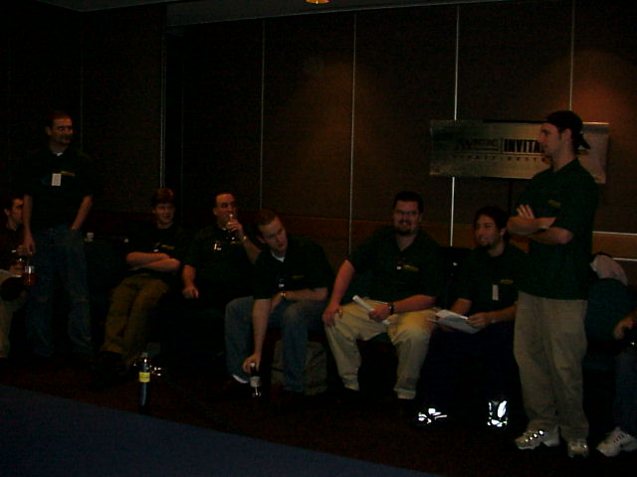
I arrived at the site to meet Omeed Dariani who had been kind enough to bring the Auction decks to Sydney. Because we did not have access to all the cards (yes, the R&D card vault is a myth), the Auction of Champions was sponsored by StarCityGames.com. Omeed promised me that he had double-checked all the decks against the card lists and that all the cards were accounted for. Unfortunately, no one had double checked the card lists themselves. As such, cards left off the lists were missing. I scrambled to find the missing cards. With the help of some of the players and a few spectators, the decks were soon all complete. It was then time to start the Auction.

At one point, Mowshowitz (playing Long's deck) screamed out, "Mike, how did you ever win with this deck?"
I had spent a lot of time thinking about how the Auction should be run. I'm not talking about the rules as those had long been spelled out, but rather about how it would work physically. We put the Auction on Saturday as we thought it would be very spectator-friendly. As it turned out, we had a very small audience as most the Grand Prix players were in the middle of the second round of the Swiss (a problem we plan on fixing in future years) and few non-players had arrived.
After much thought, I came up with the most theatric way to run the Auction. I put out sixteen chairs in a semi-circle. Players were then randomly assigned seats. At the start of each bid all the players stood up. Once a player passed in any bid, he would sit down. This created a nice effect as you would see players fall like dominoes as the bid approached its final price.
The Auction went smoothly with only one rules question. After securing Randy Buehler's PT-Chicago '97 deck, Gary Wise realized that he bid incorrectly (bidding down life rather than hand size) and wanted to know if he could underbid himself to raise his life back up to 20. I told him he could not. While there were five people present who had the ability to bid on their own deck (Budde, Finkel, Long, Maher, and Price), only Kai Budde ended up replaying history. My favorite part of the format was hearing players reevaluate decks after playing them. At one point, Mowshowitz (playing Long's deck) screamed out, "Mike, how did you ever win with this deck?"
In the end, three decks went undefeated: Kai Budde's 1999 monored Worlds deck (played by Budde), Tom Chapheng's white weenie 1996 Worlds deck (played by Gerardo Godinez) and Zak Dolan's hodgepodge 1994 Worlds deck, in the hands of Jon Finkel. Hmm, three World Championship decks played by two World Champions. Perhaps this is a good omen for Godinez.
After the players finished playing, they were asked to sign all the cards in their deck and sideboard. Star City auctioned off all seventeen decks (I signed the only unchosen deck: Sigurd Eskeland's PT NY '00) for charity. I'm not quite sure what bid each of them got, but I do know Jon Finkel's Type 1 deck sold for the most (surprise, surprise).

Type 1 - Rounds #13-15
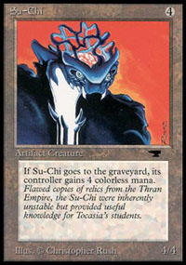
The final rounds of the Invitational are always the most fun. The top players who always stressed that they just came to have a good time starting getting serious. The thirteenth round was a bit delayed as Ben Rubin had to travel back to the hotel to get his Type 1 deck. Good thing for Rubin that the Invitational is a bit more lax than a Pro Tour because he definitely would have lost the match if we had started on time.
The key match ended up happening in the fourteenth round as two top contenders, Rubin and Price, squared off. The interesting game had Price start, going first, with a turn one Juggernaut and Su-Chi. Rubin managed to Holy Pikula the game (translation: won when victory seemed impossible) and went on to win the match. The match that seemed like it would be the most interesting happened in the fifteenth round when Jon Finkel got paired up against Mike Long. Victory assured Finkel a place in the finals where a loss most likely would knock him out (he lost to both Rubin and Price on tie-breakers - which at the Invitational is your record against the person you're tied with). Finkel sat down and said to Long, "You're the last person I want to be playing right now."
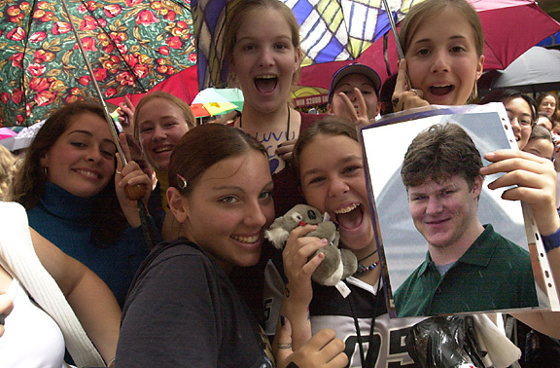
Unfortunately, this match proved pretty boring as Finkel smacked around Long and guaranteed himself a spot in the finals. Price managed to win his last match while Rubin lost his but, as they were tied, Rubin's defeat of Price the round before advanced Rubin to the finals. The next day Finkel would play Rubin in a three out of five match finals.
With the Swiss done, I went back to the hotel. On the way out I saw the remnants of the crowd that had gathered earlier to see the Backstreet Boys play live. This is where the pictures of the screaming girls came from.

For All the Marbles
In the finals of the Invitational, the two finalists play a best of five match set using all five formats of the event. While there is a default order, I let the two finalists change the order if they both agree on it. Finkel emphatically stated that he wanted to play the three Constructed formats first and the two Limited events last. He claimed that this was to speed things up and avoid a lengthy Solomon draft if it wasn't needed. While all of this is true, it also put the events Finkel had the best chance at first. Without much of a thought, Rubin agreed. Later I asked Rubin why he simply let Finkel pick the order. Rubin replied that it didn't matter as he still had to win three formats to win. But, I explained, there is a big difference between losing 3-0 and losing 3-2.
The first match was the Auction of Champions. It became clear that Finkel dominated this format when the lineup was announced. Rubin was playing Price's Tempest-only LA '97 deck with a bid of 7 cards, 13 life. Finkel, on the other hand, was playing Zak Dolan's 1994 Worlds deck with a bid of 7 cards, 15 life. Essentially, the match-up was a Type 1 deck versus a Block Constructed deck (using only a single large set) and the Type 1 deck got to start with more life.
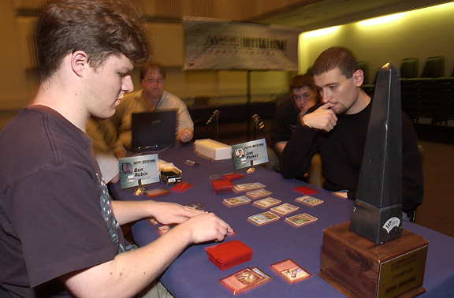
Game one cemented this unfairness home as Finkel played a turn one Serra Angel. In short, the Auction of Champions match wasn't close. As Finkel was putting away Dolan's deck he admitted that he had more respect for it than before the auction. "The cards are janky," admitted Finkel, "but they actually work together."
The second match was Type 1. Everyone felt that this match was crucial for Rubin as most believed he was at a disadvantage in the final Constructed format, B.Y.O.B. Finkel played 5-color control while Rubin played Sligh. The Type 1 games were closer than those of the Auction, with Rubin taking the second game. Unfortunately, Finkel dominated game three and Rubin conceded without any permanents in play.
The final match was B.Y.O.B. Finkel played a Tempest-Visions-Urza's Destiny "draw-go" deck while Rubin played a Tempest-Stronghold-Exodus Counter-Phoenix deck. Rubin managed to win the first game, but lost the next two. With that match under his belt, Finkel managed to add one of the few remaining unclaimed titles to his resume: Invitational Champion.

And the Award Goes to...
With the finals over, all that remained was to hold the award ceremony. The two final hiccups of the tournament happened here. First, while I had spent fifteen minutes figuring out the proper tie-breakers, the list that was read off during the award ceremony was an older list and thus the players were announced in a slightly wrong order. Second, there were only fifteen participants as Mike Long chose to no-show.
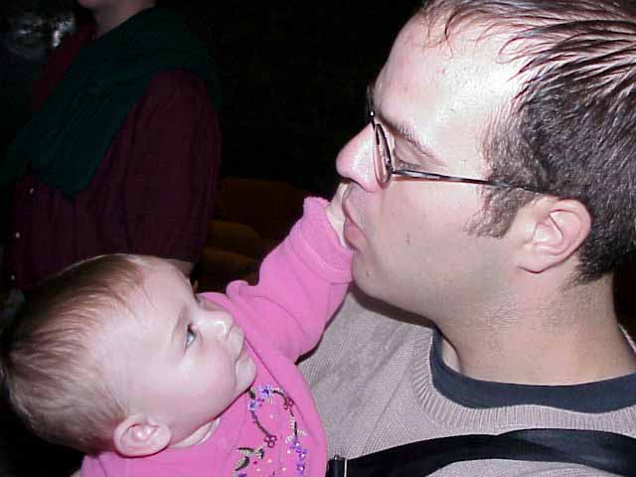
Rachel Rosewater asks the tough questions, like 'where's your tournament report, Mike Long?'
The end result of Long's absence was a disqualification from next year's event. Long had crossed the line numerous times during the event, and skipping the award ceremony was the last straw. This means Long will not be invited to the 2001 Invitational even if he wins the World Championship or the Pro Player of the Year title. In Long's defense, there were contributing circumstances, and I believe that Long was truly sorry for letting the event down, but nonetheless, responsibilities are responsibilities and I stand by his future disqualification.

Good Eats
The last night of the Invitational is always traditionally another Wizards-sponsored dinner. One of the running jokes of the Wizards dinner is that it has always been very meat-centric. Both Price and Pikula are vegetarians and always seem to have problems finding something to eat at the dinner. The problem started in Rio when the player dinner went to the restaurant with the meat dial. I don't know the Brazilian term for this cool invention but it's a little wheel that can turn to green or red. Green meant "bring more meat" while red meant "ease up on the meat". Pikula discovered that green really meant "bring more vegetables" and he griped all night about how he couldn't get enough to eat.
The next year we were in Barcelona (this was Price's first Invitational). For those of you that have never been to Spain, they, like Brazil, are big fans of meat. Every time Price and Pikula asked for a vegetarian dish, they were brought a salad. The player dinner consisted of large plates covered with numerous types of meat. When Price and Pikula begged for some non-meat food, they got, of course, a salad. Last year we were in Kuala Lumpur. I tried to take the group to an authentic Malaysian restaurant but after a mutiny we ended up at a steak and seafood restaurant.

Skaff Elias, the creator of the Pro Tour, has made it his personal goal to get a basketball game (and often numerous games) at every major Magic event that he attends...
So this year I was determined to find a restaurant that was nearby the site, big enough for twenty plus people (remember there is staff as well as the players), and had some variety of vegetarian food. After asking around, I discovered that there was a nearby Mongolian Barbecue. Back in Washington we have a nearby restaurant called Chang's that R&D and Organized Play often go to for lunch. Chang's had a full assortment of non-meat items, so I assumed Mongolian Barbecue would work fine for Price and Pikula. Unfortunately, the restaurant's non-meat selections turned out to be rather minimal and Price and Pikula were, once again, forced to seek out alternative options. Here's to hoping that Capetown has some vegetarian cuisine.
The other funny (well, I guess this is a matter of perspective) incident from dinner was the absence of Finkel and Rubin. Why would the champion and finalist miss a free dinner? To answer this question, I need to explain how basketball cross-sections with Magic. Skaff Elias, the creator of the Pro Tour (although Skaff hates this title), has made it his personal goal to get a basketball game (and often numerous games) at every major Magic event that he attends (the Pro Tours, Invitationals and U.S. Nationals). Chicago, Tokyo, Barcelona, Kuala Lumpur. Skaff has always found a place to play and has had his basketball game. Finkel, it turns out, is not too shabby on the court and plays in many of the basketball games.
The Invitational has always been a great event for basketball as the relaxed schedule allows the opportunity for both early morning and early evening games. Having found courts in the middle of Asia, Skaff had no problem with Sydney. Numerous games were played during our week in Australia. So where were Finkel and Rubin? They had rushed back to the hotel after the finals to get changed for basketball. The problem was that there was no game due to the player dinner. We got back to the hotel to find Finkel and Rubin in their basketball attire a bit peeved at the chain of the events. Everything worked out though as Finkel, Rubin, Price and Pikula all had dinner together at one of the nicer restaurants in the hotel.

A Night to Remember
The final night of any Pro Tour is always the most fun as the players and staff, now done with the tournament, can stay up all night and play Magic. The most memorable part of the final night from Sydney involves Pikula. Because Finkel had won the finals in three matches, I had an extra Solomon Draft that no one had used. With his 0-10 record in Solomon Draft, I figured Pikula should have first dibs on it as, well, he could use the practice. Pikula ended up drafting against Bob Maher, who it turns out Solomon drafts quite a bit back home.
For the first time, here are the decks that would have been used if Finkel and Rubin had made it to match five:

Solomon Draft (Finals)
Pack #1
Player A Player B
Cho-Arrim Legate Orcish Farmer
Corrupt Yavimaya Elder
Carpet of Flowers Shimmer
Mogg Alarm Choking Sands
Pack #2
Player A Player B
Kavu Scout Waiting in the Weeds
Global Ruin Granite Grip
Avenger en-Dal Bad River
Submerge Gemstone Mine
Pack #3
Player A Player B
Geothermal Crevice Astrolabe
Abolish Moor Fiend
Soldevi Sage Orcish Lumberjack
Viscerid Drone Village Elder
Pack #4
Player A Player B
Lumbering Satyr Blanket of Night
Frenzied Tilling Flowering Field
Collective Restraint Tek
Thran Quarry Mountain Valley
Pack #5
Player A Player B
Exotic Curse Celestial Dawn
Rampant Growth Phyrexian Infiltrator
Floodgate Reverent Silence
Braidwood Sextant Wandering Stream
Pack #6

Player A Player B
Spitting Earth Lotus Vale
Daze Reflecting Pool
Tinder Farm Befoul
Overabundance Planar Birth
Pack #7
Player A Player B
Mountain Yeti Dream Thrush
Deepwood Legate Excavator
Infernal Harvest Crash
Angelic Favor Sulfur Vent
Pack #8
Player A Player B
Bull Hippo Crystal Spray
Benthic Explorers Lingering Mirage
Strength of Unity Goblin Scouts
Mire Shade Dire Wolves
Pack #9
Player A Player B
Funeral Charm Wayfaring Giant
Mulch Blanchwood Armor
Thunderclap Tonic Peddler
Grasslands Meddling Mage
Pack #10
Player A Player B
Massacre Charm Peddler
Irrigation Ditch Phantasmal Fiend
Army Ants Rocky Tar Pit
Foratog Sivvi's Ruse
Pack #11
Player A Player B
Vug Lizard Tribal Flames
Fungus Elemental Mystic Compass
Magical Hack Blighted Shaman
Trenching Steed Fireblast
Pack #12
Player A Player B
Sand Squid Kukemssa Serpent
Thwart Power Armor
Flood Plain Jeweled Spirit
Ancient Spring
I'd like to tell you that it was an exciting match or that Pikula looked like he might finally break his streak, but it wasn't. Maher defeated Pikula handily.

Farewell
And that, in a giant nutshell, is my Invitational experience. As always, I had a very good time and the event ran rather smoothly. I had an excellent time in Sydney and recommend a trip to Australia for anyone who has never been.
I know I've missed a few small details, but I plan to cover those in part three of my report. Just kidding!
This year's Invitational will take place Oct. 5-7 in Capetown, South Africa. This will be the fifth continent for the Invitational and I'm quite eager to finally visit Africa.
As a quick reminder, here is the criteria for this year's event:
1) Last Year's Magic Invitational Champion
2) 2001 World Champion
3) Highest Ranked DCI Member
4) Highest Ranked Player, Pro Points
5) 2nd Highest Ranked Player, Pro Points
6) 3rd Highest Ranked Player, Pro Points
7) 4th Highest Ranked Player, Pro Points
8) 5th Highest Ranked Player, Pro Points
9) Top Ranked North American, Pro Points
10) Top Ranked Latin American, Pro Points
11) Top Ranked European, Pro Points
12) Top Ranked APAC, Pro Points
13) Highest Ranked Player, Fan Ballot
14) 2nd Highest Ranked Player, Fan Ballot
15) 3rd Highest Ranked Player, Fan Ballot
16) 4th Highest Ranked Player, Fan Ballot
DCI Ratings
DCI rating invitations will be based on composite ratings effective August 15, 2001.
Fan Ballot
The ballot is posted on Sideboard.com through August 22, 2001. Only DCI members may vote. One vote per member. Vote here.
Invitation Pass Downs
Invitations based on winning an event (Invitational Champion & World Champion) pass down to the Fan Ballot. Invitations based on a ranking (#7-#16) will pass down to the next qualified player on the same list.
I hope you all participate in this year's balloting as the player involvement is a big part of what the Invitational is all about. Also, please follow this year's coverage on the Sideboard. The Invitational is the one event in Magic designed specifically to provide the best online coverage possible.
Until then, may all your tournament reports be just a little less lengthy!

